___________________________________________________________________________________________
---Camel Casing & Pascal Casing for Naming Identifiers ---

Camel casing is when the first word is lower case and the rest of the words are Capitalized.

Ex.
countOverFifty

*- Camel casing is always used for local variables. -*

Pascal casing is when every word is capitalized.

Ex.
CountOverFifty

*- Pascal casing is always used for methods. -*

___________________________________________________________________________________________
---Creating Identifiers---

- Identifiers can start with an underscore, @, or a letter.
- Identifiers can only contain letters, digits, underscores, and @.

___________________________________________________________________________________________
---Characters and Strings---

- Characters are denoted by ' ' and can only contain one character.
- Strings are denoted by " " and can contain many characters.

Ex.
'a' - character
"abdefg" - string
'9' - character

___________________________________________________________________________________________
---Literal Constants---

Literal constants are values that do not ever change. They could be a variable or in an expression.
Ex.
int aNumber = 1; - 1 is the literal constant

Ex.
Console.WriteLine(6 + 5); - 6 and 5 are literal constants

*- You shouldn't have literal constants in your code (magic numbers), instead make
them named constants. -*

Conventions:
a = 1 - assumed int because there is no decimal
a = 1.1 - assumed double because there is a decimal

???
a = 1M
{value: C} - to format an int when you display it
???

___________________________________________________________________________________________
---Escape Sequence Characters---

Putting a \ before a character will change the meaning of that character.

\' - a single quote
'\n' - new line
'\t' - tab

Ex.
Console.WriteLine("Some writing \' and some more writing.");
output:
Some writing ' and some more writing.

Ex.
Console.WriteLine("Some writing \nand some more writing.");
output:
Some writing
and some more writing.

Ex.
Console.WriteLine("1\' 2\"");
output:
1'2"

___________________________________________________________________________________________
---Comparing Characters Using Boolean Operators---

Each character is represented by unicode. When comparing characters, it compares each character's unicode.

- Whatever letter has a lesser unicode value is considered less than a character with a higher unicode value.
- When comparing strings, two strings would be considered equal if every single character is the same in both strings.

Ex.
'a' < 'A' = true - because lower case unicode comes before upper case

Placeholders (are a nightmare, use string interpolation instead)

___________________________________________________________________________________________
---Displaying Formatted Strings---

Putting $ before the "" of a string is called string interpolation, and it lets you put variables into a string or format the look of the string's output using {}.

Ex.
int aNumber = 25;
Console.WriteLine($"Here is a number: {aNumber}");
output:
Here is a number: 25

- You can use a second argument in {} to format how the output is displayed. This example uses a positive number to tell it where the strings will end.

Ex.
string name1 = "Greg";
string name2 = "Judy";
string name3 = "Bob";

Console.WriteLine($"{name1, 15}");
Console.WriteLine($"{name2, 15}");
Console.WriteLine($"{name3, 15}");
output:
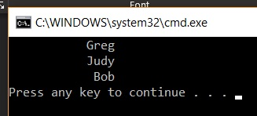

- Putting a “-“ before the number tells it how many spaces to take up.
Ex.
string name1 = "Gregory";
string name2 = "Judy";
string name3 = "Bob";

Console.WriteLine($"{name1, -8}{name2, -8}{name3, -8}");
Console.WriteLine($"{name2, -8}{name1, -8}{name3, -8}");
output:
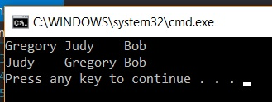

___________________________________________________________________________________________
---Table of Formatting Floating-Point Values---

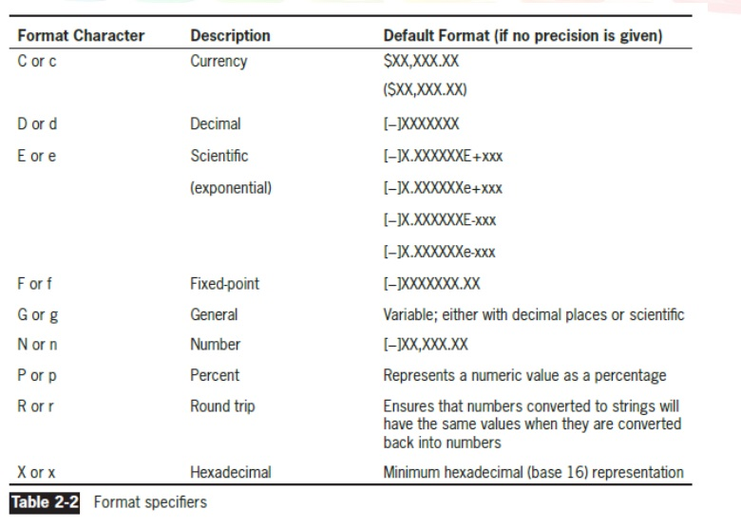

*- Fixed-point lets you specify the number of decimal digits, General lets you specify the number of significant digits. -*

Ex.
double number1 = 6.5686;
int number2 = 6;

Console.WriteLine($"{number1:f7}\n{number2:f1}");
output:
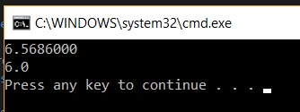

- You can use “:c” to format a number to appear as currency.

Ex.
int someMoney = 5;
Console.WriteLine($"This will look like money, {someMoney:c}");
output:
This will look like money, $5.00

___________________________________________________________________________________________
---Floating Point Datatypes---

- Put an F after a number to make it a float
- Put a D after a number to make it a double
- Put an M after a number to make it a decimal
- Put an E for scientific notation

??? I don’t know when this is necessary because variables are already defined as one of these when created ???

___________________________________________________________________________________________
---Named Constants---

- Named constants do not use camel or pascal casing, instead every letter is capitalized and underscores are used to separate words for readability.
- Named constants replace magic numbers.
- You will not be able to change the value of this variable throughout your program.

Ex.
const double KILOS_IN_POUNDS = 0.56975;

___________________________________________________________________________________________
October 1, 2019

---Conditionals (if else statements)---

Everything in an "if statement" is only done if the "if statement" is true, otherwise nothing happens.

Ex.
if (this is where you put a logical expression that gives a boolean true or false)
{
everything you put between the curly brackets is what happens if the if is true;
}

Everything in an "else" happens anytime an "if statement" is false.

Ex.
if (aVariable < 10)
{
if aVariable < 10 = true, everything between the curly brackets is done;
}
else
{
if aVariable < 10 = false, everything between these curly brackets is done;
}

___________________________________________________________________________________________
---Logical Operators---

Logical operators return a value of either true or false. They can be binary or unary.

- Binary logical operators are true if either one of the two arguments is true.
- Unary logical operators have only one argument that is true or false.

Binary:
== - is equal to
!= - is not equal to
<= - is less than or equal to
>= - is greater than or equal to
&& - and
|| - or
> - is greater than
< - is less than

Unary:
! - not

___________________________________________________________________________________________
October 10, 2019

---Switch---

Keywords: switch, case, break, default

- Switch is used for matching values.
- Switch does not have a fall through rule, you must use "break".
- Cannot be used for logical expressions (boolean values true & false).
- Cannot be used to compare decimal numbers (single, double, decimal).

- Always put "break;" at the end of every case.
- "Default" will catch every other case (like else). It is not mandatory.

- Switch will also match based on type.

Ex.
switch (aVariable)
{
case 1:
Console.WriteLine(“One”);
break;
case 2:
Console.WriteLine(“Two”);
break;
case int x:
Console.WriteLine(“This variable is an integer.”);
break;
default:
Console.WriteLine(“This case catches everything else.”);
break;
}

